**MAC 220 Final Project**

Team Members : Mushfiqul Islam, Kazi Safayat Huq

Submitted To : Prof. Praveen Kumar

Submission Date : 6-6-2021

1.What is the name of our android app?

- The name of our app is ‘Make-A-Change’

2.What are the key concepts of this app?

- This is mainly a productive daily routine app where users will be able to monitor their daily activities and keep track of their daily routine. In this digital age, being productive is one of the challenging jobs especially when you have so many distracting things around you. That is why we came up with **"Make-A-Change''**.

3.What items of the Android Studio did we use for creating this project? What are the logics behind making this app functioning?

- We used **multiple activities** to get **multiple layouts** and **views**. In the main activity, we brought into play three buttons for connecting with three activities.

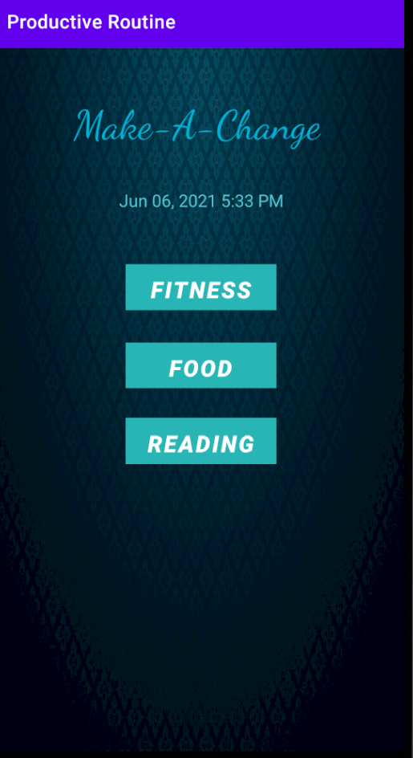

For each and every activity, we exercised **Constraint Layout** and **ScrollView.**

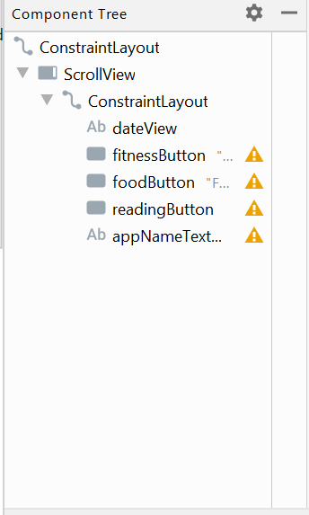

We also added up some common palettes such as Button, Label, checkedText, dropdown icon etc for giving user a good user interface experience.

When user will be navigating through different options from the main activity, they can visit the other activities from their present activity just by pressing the **‘Menu’** option which is located on the top-right side of the screen.

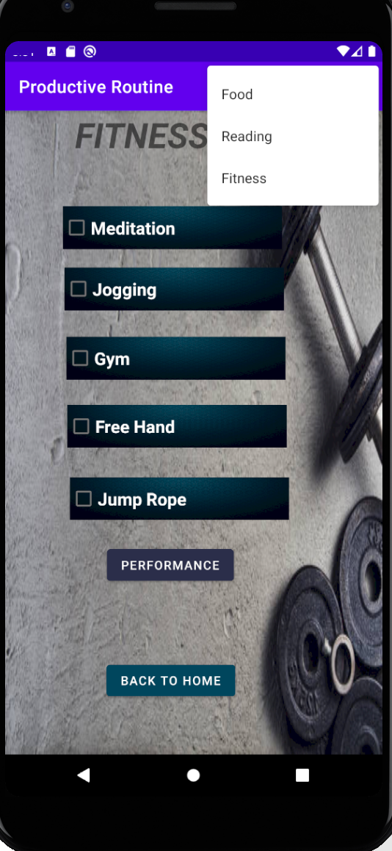

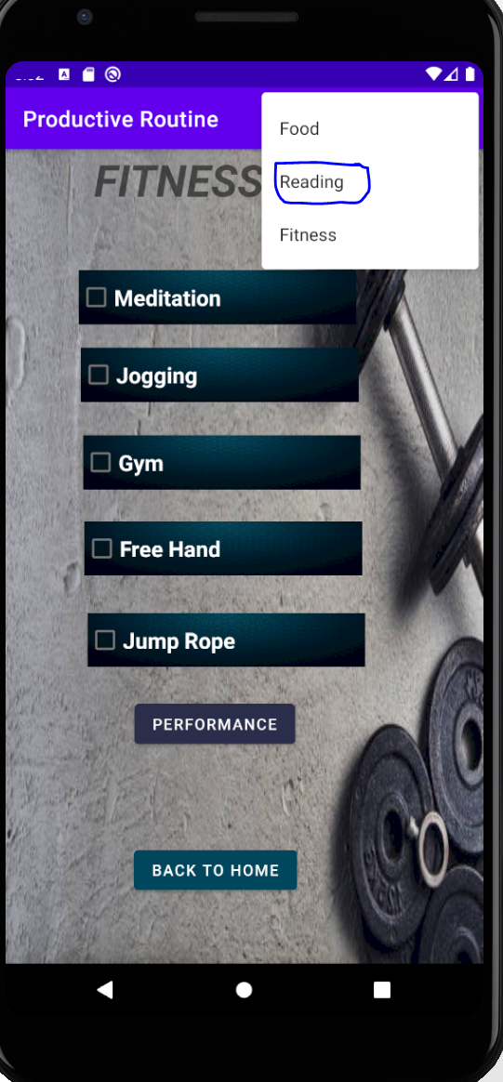

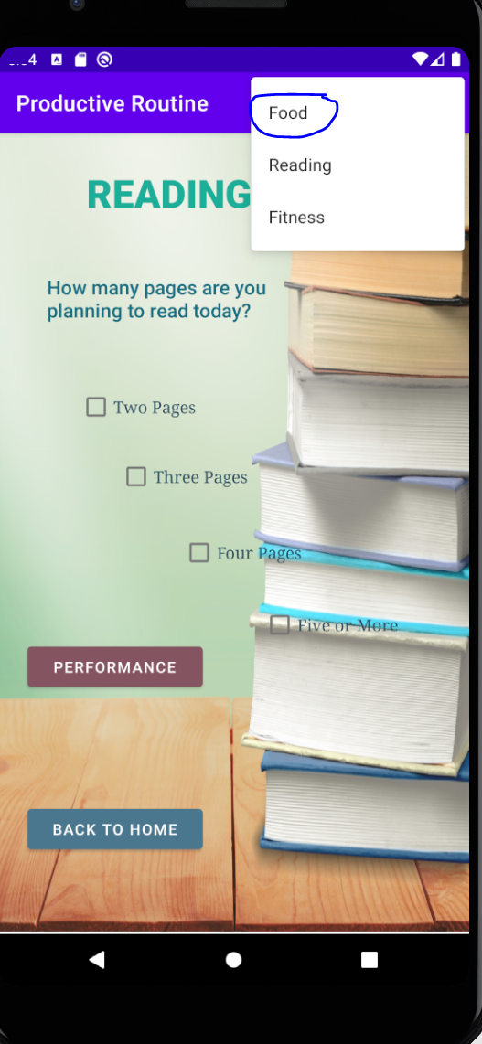

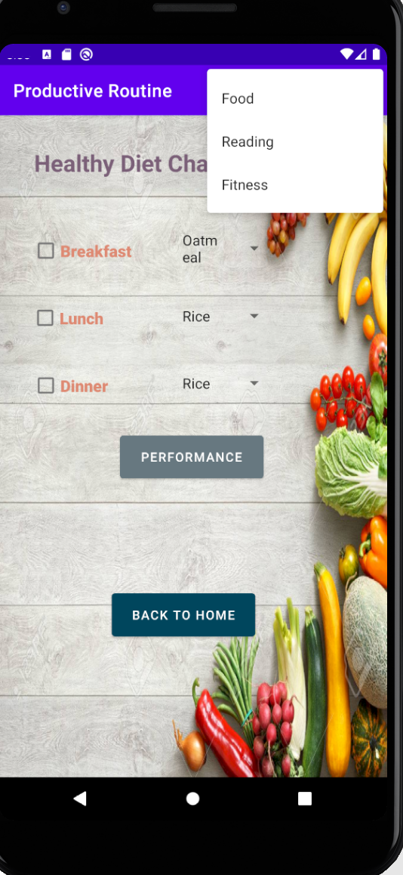

In the main activity, we used currentTimeMillis() and SimpleDateFormat to manifest current time and date.

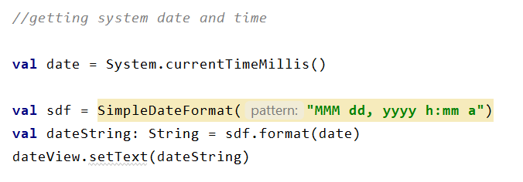

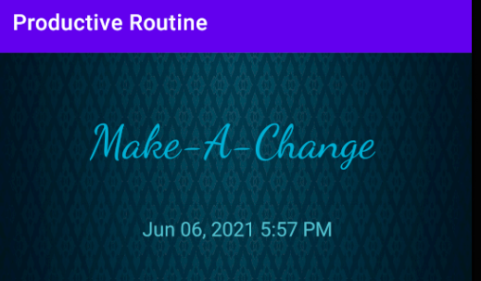

We connected multiple activities by simply adding **setOnClickListener** with the buttons.

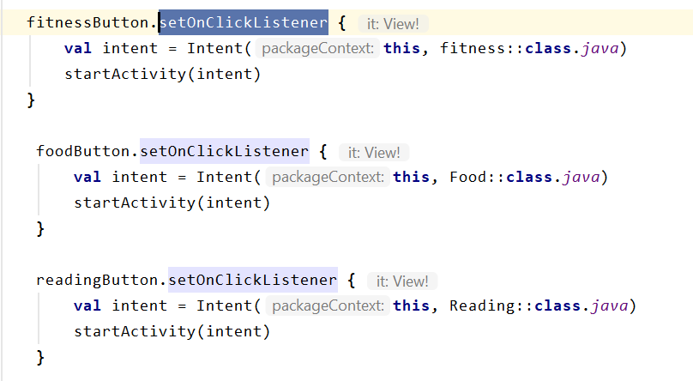

In every activity except the main, **if-else conditional statement** have been used. User will be able to know through a message based on how productive they were throughout the day.

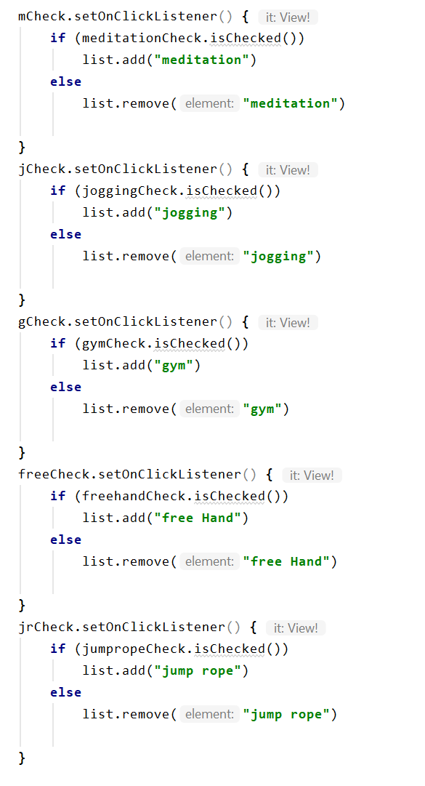

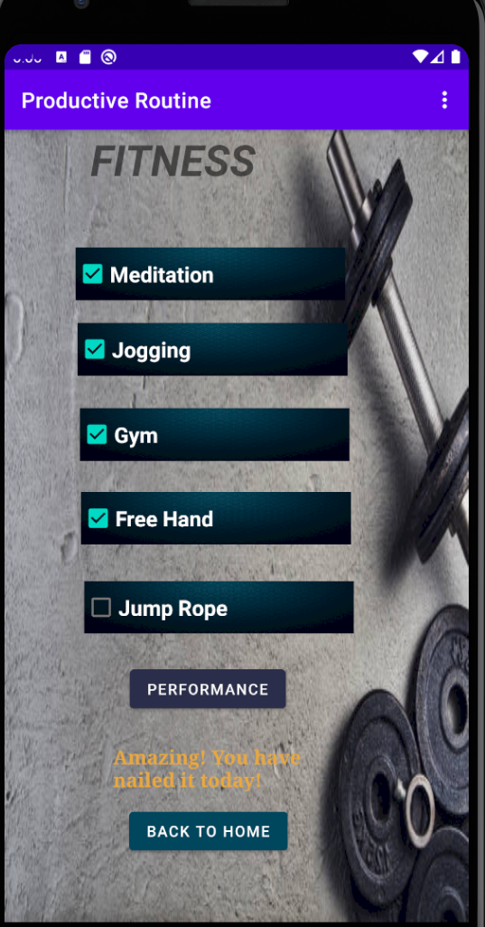

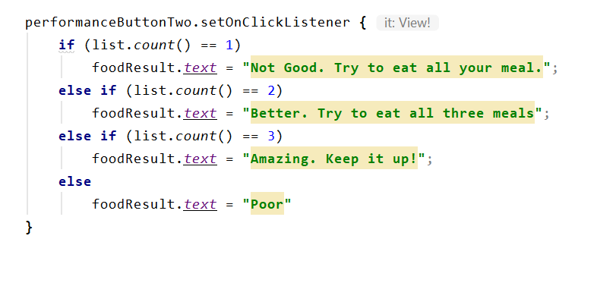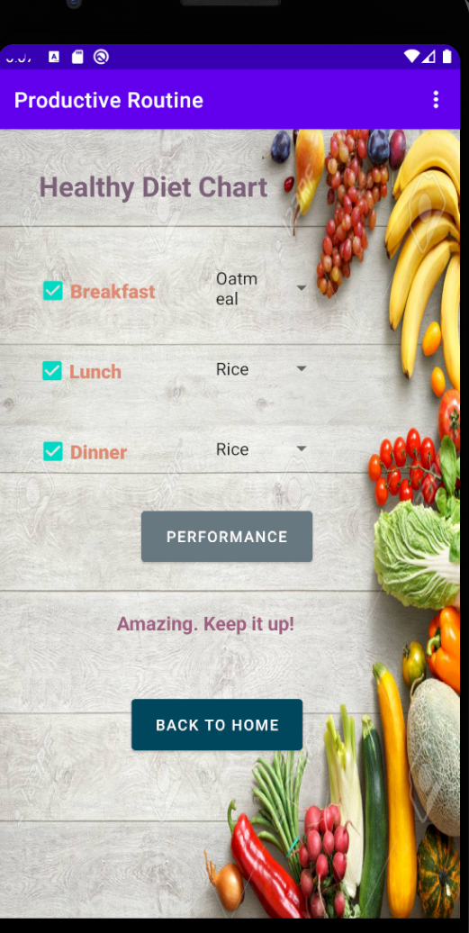

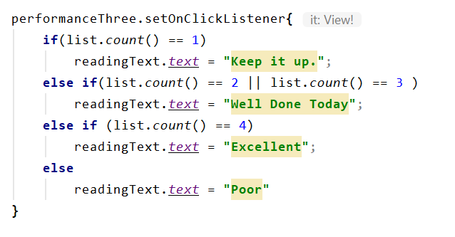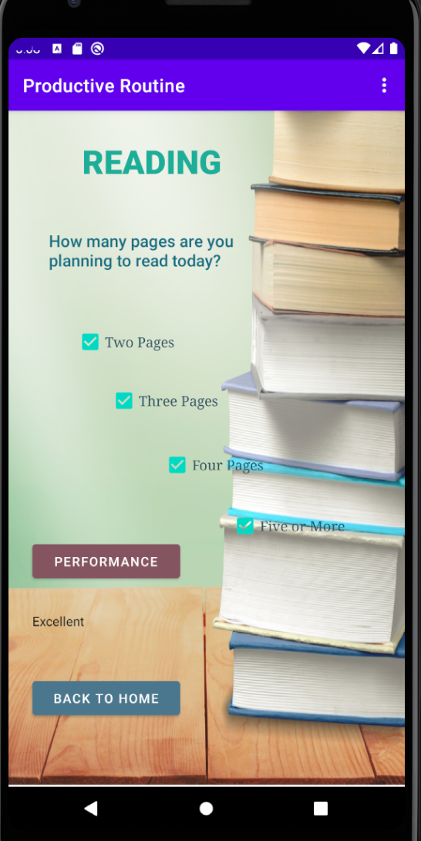

For setting up dropdown menu and assigning the values to dropdown menu we used couple of variables and arrayAdapter and assigned the adapter to the id of the dropdown menu.

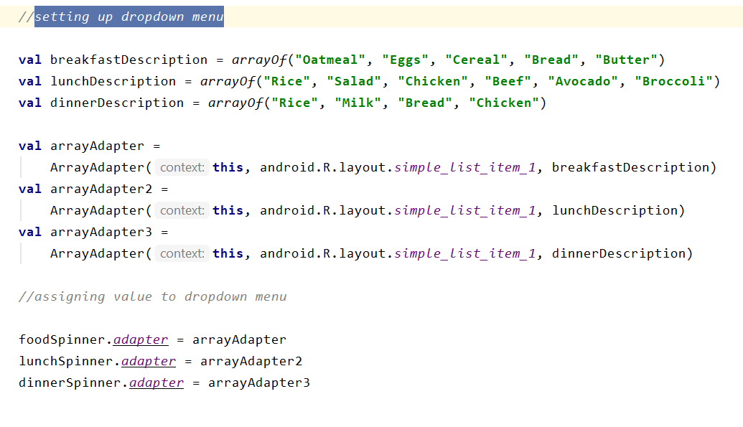

To count and store checkbox data we used ArrayList() and to add them in the declared array we used list.add() and to remove list.remove() has been used.

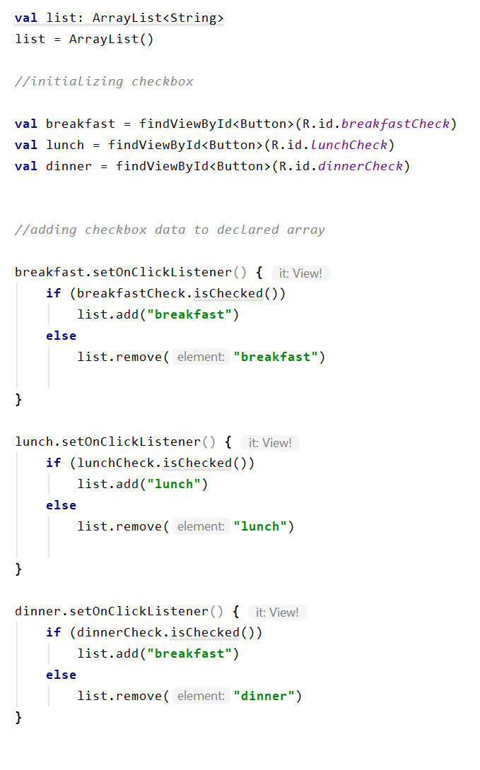

Moreover, they can go back to ‘Home’ anytime by simply clicking on the ‘Back To Home’ button. For this reason, we used Intent() along with the main activity class.

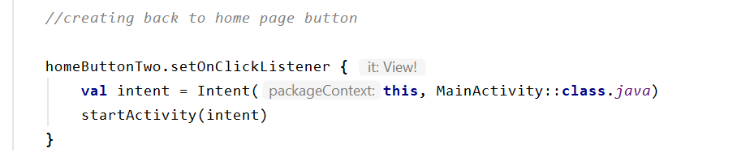

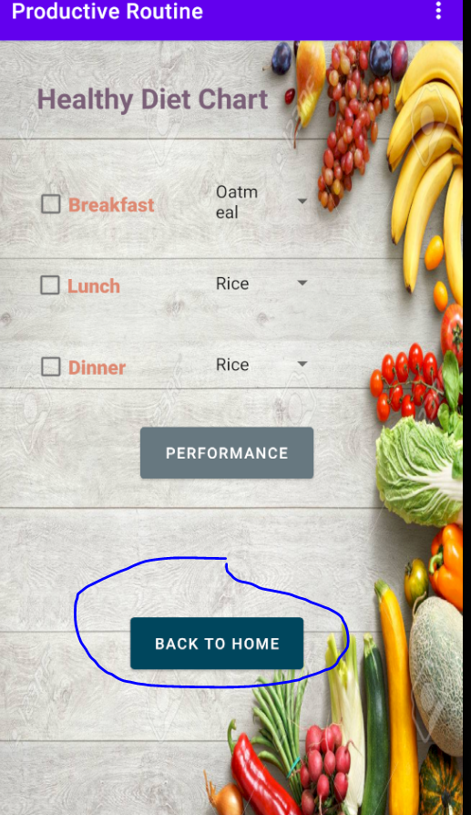

4.How did you solve the rotation issue?

- This app can be scrolled down as well as rotated whenever user wants. We used ‘Contraint Layout’ and most importantly ‘ScrollView’ to make sure the contents of the app gets rotated when the screen rotates. It also save all the states while it performs rotation.

